Ideation Phase
Empathize & Discover — Empathy Map Canvas

Student Name | Bantupalli Niharika
Project Name | Automated Network Request Management
Maximum Marks

Empathy Map Canvas
Dimension | Employee / End User Perspective
Says | I need a simple and quick way to request network services.
Thinks | I want only relevant options and a guided request form.
Does | Opens the Service Portal, selects the Network Request catalog item, fills in the details, and submits the request.
Feels | Wants a fast, reliable, and transparent network service experience.
Pain Points | Incomplete request information, unclear forms, delayed processing, and limited request-status visibility.
Needs / Goals | Guided request submission, complete information capture, automated approvals and task fulfillment, timely notifications, and status tracking.

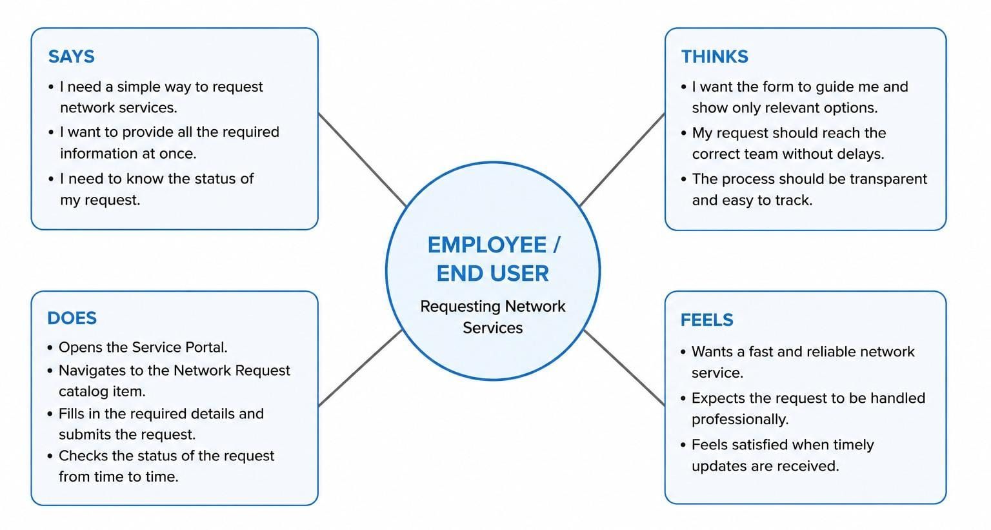
Automated Network Request- Empathy Map
MAIN POINTS
Incomplete requests • unclear forms • delayed processing • limited status visibility
Figure 1: Employee perspective empathy map representation for the Automated Network Request & Fulfillment Management project.

